# CS 255 System Design Document

CS-255 Project Two

Lamberto Nunez

8/11/2025

## UML Diagrams

### UML Use Case Diagram

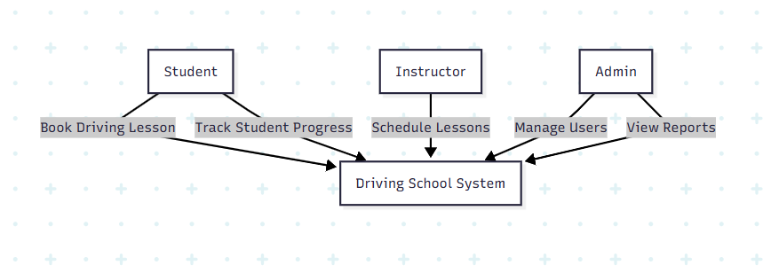

### UML Activity Diagrams

*Book A Driving Lesson*

*Track Student Progress*

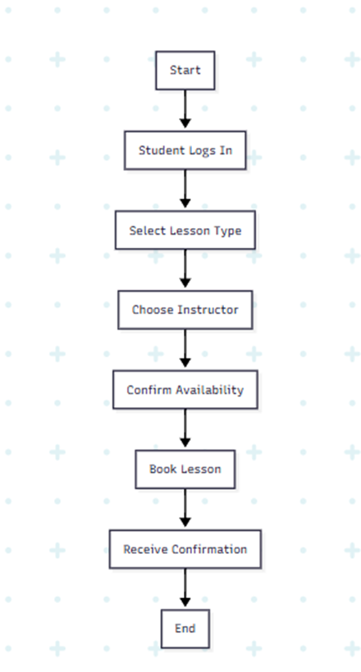

### UML Sequence Diagram

### 

### UML Class Diagram

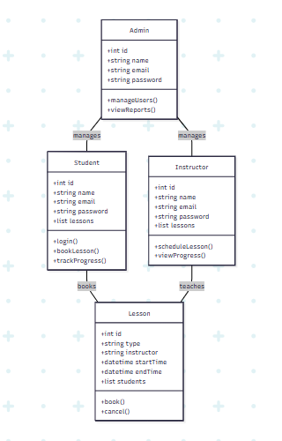

## Technical Requirements

***Hardware & Infrastructure***

* ***Cloud-hosted Environment****: The system will be hosted on a cloud platform (AWS or Azure) to ensure scalability and reliability.*
* ***Load Balancing****: To handle concurrent users (500+), load balancing will be implemented to distribute traffic across multiple servers.*
* ***Relational Database Server****: A relational database server (PostgreSQL or MySQL) will be used to manage data.*
* ***Web Hosting****: The application will be hosted on Unix-based servers for better performance and security.*
* ***Backup and Recovery****: Regular backups of the database and application data to ensure data integrity and quick recovery in case of failures.*

***Software***

* ***Frontend****: The frontend will be developed using React.js to ensure a responsive and user-friendly interface.*
* ***Backend****: The backend will be developed using Node.js with Express.js for handling server-side logic.*
* ***Database****: PostgreSQL will be used as the primary database system for its robustness and scalability.*
* ***Security****: HTTPS/SSL will be implemented for secure data transmission. Token-based authentication (JWT) will be used for user authentication.*
* ***APIs****: RESTful APIs will be developed to facilitate communication between the frontend and backend.*

***Tools***

* ***Version Control****: Git will be used for version control to manage code changes and collaborate with team members.*
* ***CI/CD Pipeline****: A Continuous Integration/Continuous Deployment (CI/CD) pipeline will be set up to automate the deployment process and ensure smooth updates.*
* ***Modeling Tools****: Mermaid, Lucidchart, Draw.io will be used for creating UML diagrams and other visual models.*
* ***Project Management****: Trello or Jira will be used for project management and tracking progress.*

***Security***

* ***Authentication and Authorization****: Secure login with two-factor authentication (2FA) will be implemented to enhance security.*
* ***Data Encryption****: Data will be encrypted both in transit and at rest to protect sensitive information.*
* ***Account Lockout****: Accounts will be locked after a specified number of failed login attempts to prevent brute force attacks.*
* ***Admin Alerts****: Admins will receive alerts for suspicious activities and password recovery requests.*

***Performance***

* ***Scalability****: The system will be designed to scale horizontally to handle increased load.*
* ***Load Time****: The web application will be optimized to ensure a load time of less than 2 seconds for better user experience.*

***System Limitations***

* ***Payment Processing****: Payment processing will not be included in Phase 1.*
* ***Mobile App Features****: Limited mobile app features will be available in Phase 1.*
* ***Third-Party API Integration****: No third-party API integration will be implemented in Phase 1.*